Project 2 Proposal

Project members: Lauren Calso, David Colonia, David Cruz, Phillip Sohn, Trip Beernink

Title: Bike Project

Topic:  Bike Project is a transportation website which includes an open source bike registry, amongst additional datasets.

Rationale: This bike website will verify the bikes by using plotly to mark sharing stations in the Bay Area. In addition, we will compare the volume of available bikes to cars. The user interface and features will include location search, search filters, bike specifications, and info guides to attract the bike buyer.

Data Set (must have at least 100 records):

<https://www.kaggle.com/saulfuh/bart-ridership>

<https://www.kaggle.com/datasf/san-francisco>

Screenshots of relevant visualizations:

Visualizations include:

* Python, Flask, SQLAlchemy
* HTML/CSS, Bootstrap, JavaScript

JS library: Mapbox.js, D3.js

Sketch of final design:

Dashboard page with multiple charts all updating from the same data

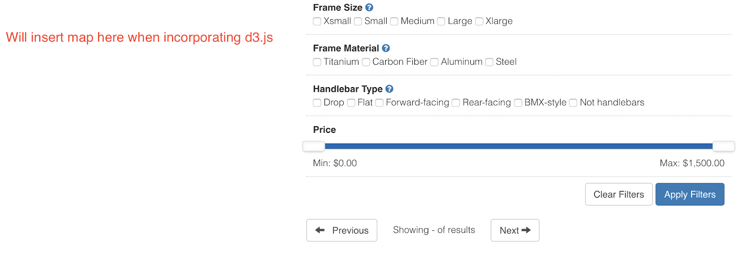

GitHub project 2 repository: https://github.com/LCalso/Project-2_Bike-Project